Unit Five: Dramatic Examples

Underscoring in a dramatic musical may, at times, be heavier and fuller than in a comedic setting. One great example to look at is the latter half of the second act of South Pacific which contains many war scenes. In order to build the tension, the full orchestra underscores a lot. In a more contemporary show, The Secret Garden, this technique may be used, but lighter more sparse underscoring is more commonly found.

In this first example, we can see the sound of the robin. Make a note of how the cue is indicated.

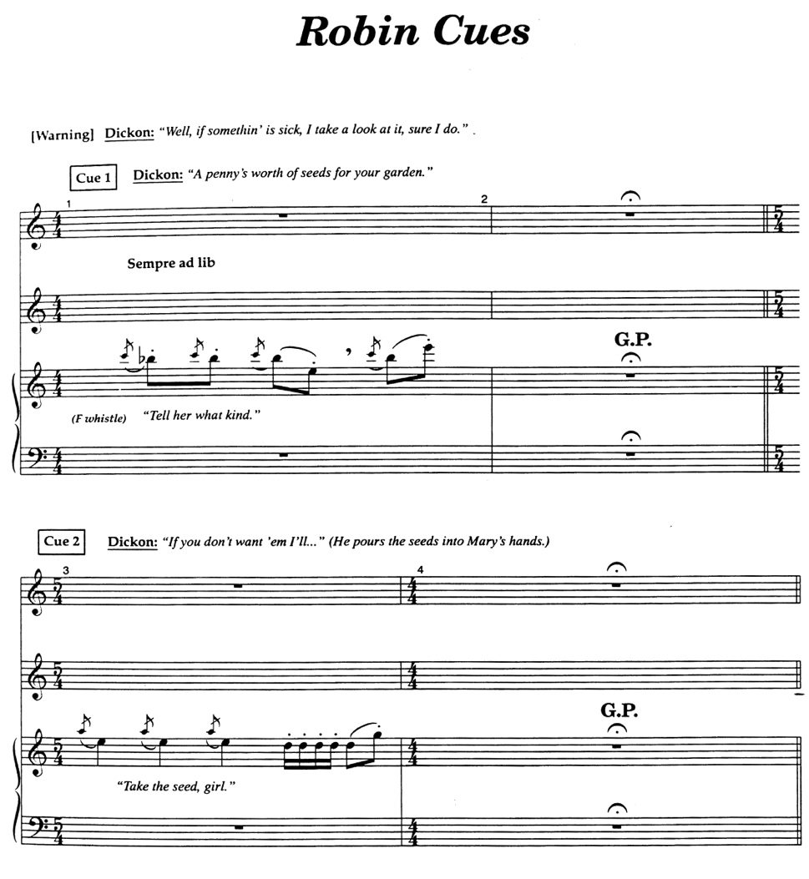

In this second example, note how the sting brings to mind the memory of life in India, how simply it is orchestrated and how clear the cue is indicated.
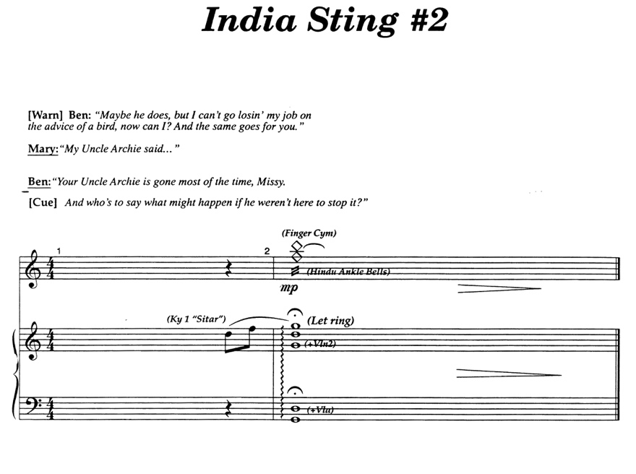

Finally, in this final example, make a note of how the dialogue cues are indicated in relationship to the building chords.
