Unit Five: Comedic Examples

Particularly in comedy, underscoring can be quite light. As indicated in the example below from Avenue Q, it can be a simple well-timed chord. Notice that it is played in a register higher than the spoken voice.

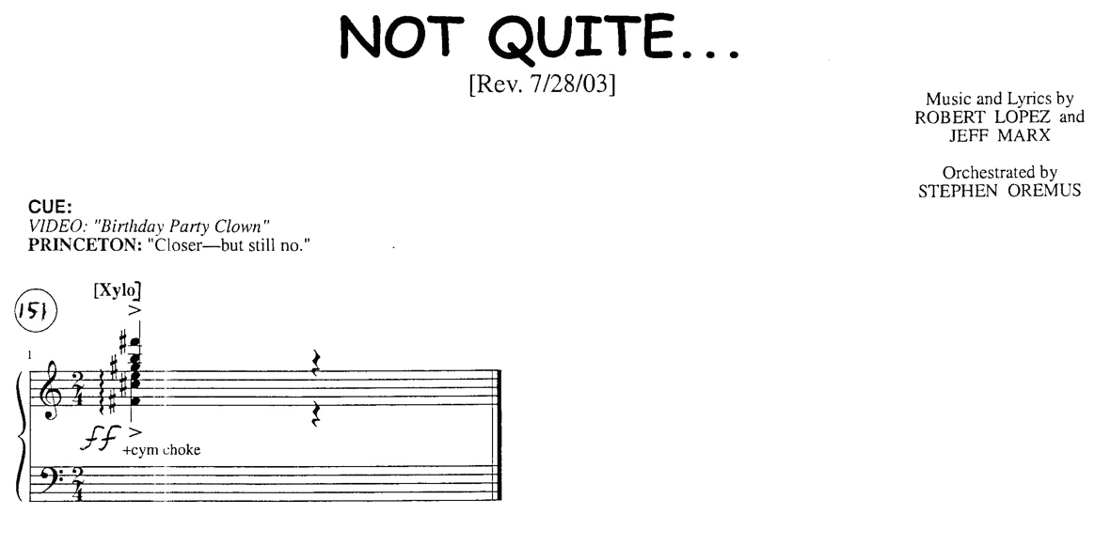

In the next example, below, the underscoring is a simple bell tree. When using underscoring, it can be tempting to write too much. Sometimes, shorter, lighter sound or musical motives work better.

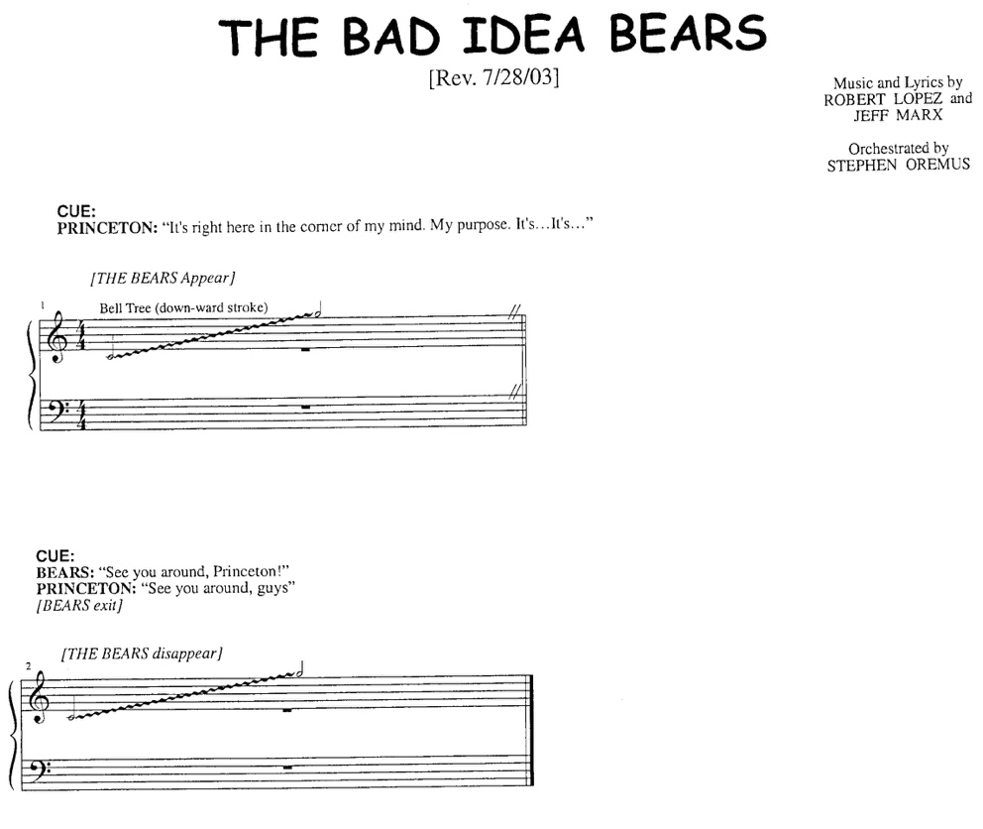

In this final example from Avenue Q, please not how light the texture is and how lightly scored the idea is. You can also see how the cues are indicated at the end of the line for the release of the fermata. In more contemporary shows, underscore is often used very lightly and sparingly.

